# 

# 

# Phase -3

Detecting market trends by analyzing financial reports and economic indicators

**Student name –** Anuja K

**Register number –** 411823243003

**Institution –** RRASE College of engineering

**Department –** B. tech (AI&DS)

**Date of submission –** 14 -05 - 2025

**GITHUB Repository link –** [**https://github.com/anuja2244/anuja**](https://github.com/anuja2244/anuja%20%20%20%20%20%20)

1. **Problem statement**

In the fast-paced and data-rich financial environment, identifying market trends is essential for investors, policymakers, and businesses. However, the vast volume of unstructured financial reports and complex economic indicators makes manual analysis inefficient and error-prone. There is a need for an intelligent, automated system that can analyze financial texts and quantitative economic data to detect, predict, and visualize market trends accurately and in a timely manner.

1. **Abstract**

This project aims to develop a data-driven approach for detecting market trends by analyzing financial reports and economic indicators. By leveraging natural language processing (NLP) techniques, the system

Simultaneously, time-series analysis is applied to structured economic data such as GDP, inflation, and unemployment rates. These insights are integrated using machine learning models to identify emerging market trends and forecast potential shifts. The outcome is a robust decision-support tool that enhances financial forecasting and supports strategic investment decisions with greater accuracy and efficiency.

1. **System requirement**

**Hardware**

* **Processor:** Intel i5/i7 or equivalent (minimum quad-core)
* **RAM:** 8 GB (16 GB recommended for large datasets and NLP models)
* **Storage:** 256 GB SSD (or more, depending on data size)
* **Operating System:** Windows 11

**Software**

* **Programming Language:** Python 3.8
* **Data Handling:** Pandas, numpy
* **Machine Learning:** Scikit-learn, TensorFlow or PyTorch
* **Visualization:** Matplotlib, Seaborn, plotly
* **Time-Series Analysis**: Statsmodels, Prophet
* **Development Environment:** Jupyter Notebook, VS Code, or PyCharm
* **Dashboard Tools:**  Power BI for visualization
* **Version Control:** Git and GitHub

1. **Project objectives**

* Collect and preprocess data from financial reports and economic indicators using automated pipelines.
* Apply Natural Language Processing (NLP) techniques to extract sentiment, keywords, and topics from financial texts.
* Analyze economic indicators (e.g., GDP, inflation, interest rates) using time-series methods to identify patterns.
* Integrate textual and numerical data to build a comprehensive dataset for trend analysis.
* Develop machine learning models to detect and predict market trends based on combined features.
* Visualize insights and trends using interactive dashboards and visual tools for stakeholder understanding.
* Evaluate model performance to ensure accuracy, scalability, and reliability of trend detection.

1. **Project workflow(flow)**

**Data collection**

**Data cleaning**

**Exploratory data analysis (EDA)**

**Insight generation**

**Visualization**

**Recommendations**

1. **Dataset description**

**Dataset name:** financial analysis

**Source:** take from via Kaggle

**Data type:** structured

**Records and features:** 3265 to 3000 samples

**Static or Dynamic:** static dataset

**Screenshot of sample record:**

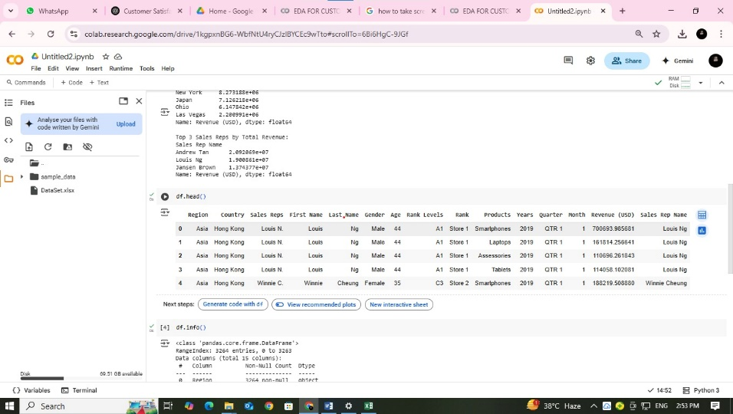

1. **Data preprocessing**

**Financial Reports (Text Data):**

* + **Text Extraction:** Convert PDFs or HTML reports into plain text.
  + **Cleaning**: Remove HTML tags, special characters, and non-informative content.
  + **Tokenization:** Break text into words or phrases.
  + **Stop word Removal:** Eliminate common, non-informative words (e.g., "the", "and").
  + **Stemming/Lemmatization:** Reduce words to base forms (e.g., "growing" → "grow").
  + **Sentiment Scoring:** Use NLP models (e.g., VADER, Fin BERT) to assign sentiment values.
  + **Keyword/Topic Extraction:** Identify important terms and topics using TF-IDF or LDA.

**Economic Indicators (Numerical Data):**

* **Data Cleaning:** Handle missing values, duplicates, and outliers.
* **Normalization/Scaling:** Standardize data for machine learning models.
* **Time Alignment:** Ensure all indicators are aligned by consistent time intervals (e.g., monthly, quarterly).
* **Feature Generation:** Create derived features (e.g., moving averages, percentage change).
* **Lag Features:** Capture delayed effects of indicators on markets.

1. **Exploratory data analysis (EDA)**

**Univariate Analysis:**

* Distribution of revenue growth rates
* Frequency of positive/negative earnings surprises

**Bivariate/Multivariate Analysis:**

* Heat map for Total revenue by rank
* Donat chart between total revenue and average revenue by region
* Stacked bar chart for total revenue by rank and products

**Visuals:**

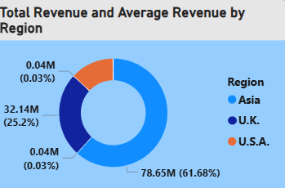 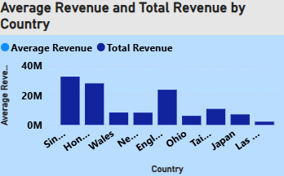

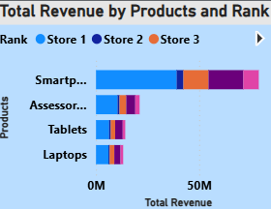 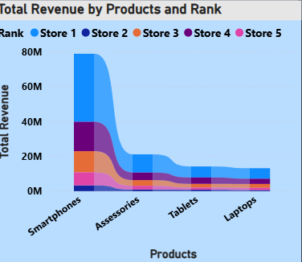

**Insights Example:**

* Market indices show strong positive correlation with GDP growth.
* Sectors like technology outperform during low-inflation periods.
* Negative earnings surprises often precede short-term price declines.

1. **Insights and interpretation**

* Economic indicators such as GDP and inflation are leading predictors for market trend reversals.
* Financial ratios (e.g., P/E, ROE) help identify undervalued or overvalued sectors.
* Market downturns are often preceded by declining corporate earnings and rising unemployment rates.
* Diversification into sectors resilient to macroeconomic shocks can reduce portfolio risk.

1. **Recommendations**

**Short-Term Actions:**

* Monitor quarterly earnings and key economic releases for early trend signals.
* Adjust portfolio allocations based on sectoral trends and macroeconomic outlook.

**Long-Term Strategic Moves:**

* Develop automated dashboards for real-time trend monitoring.
* Integrate alternative data sources (e.g., sentiment analysis from news/social media).

1. **Visualization/ Dashboard**

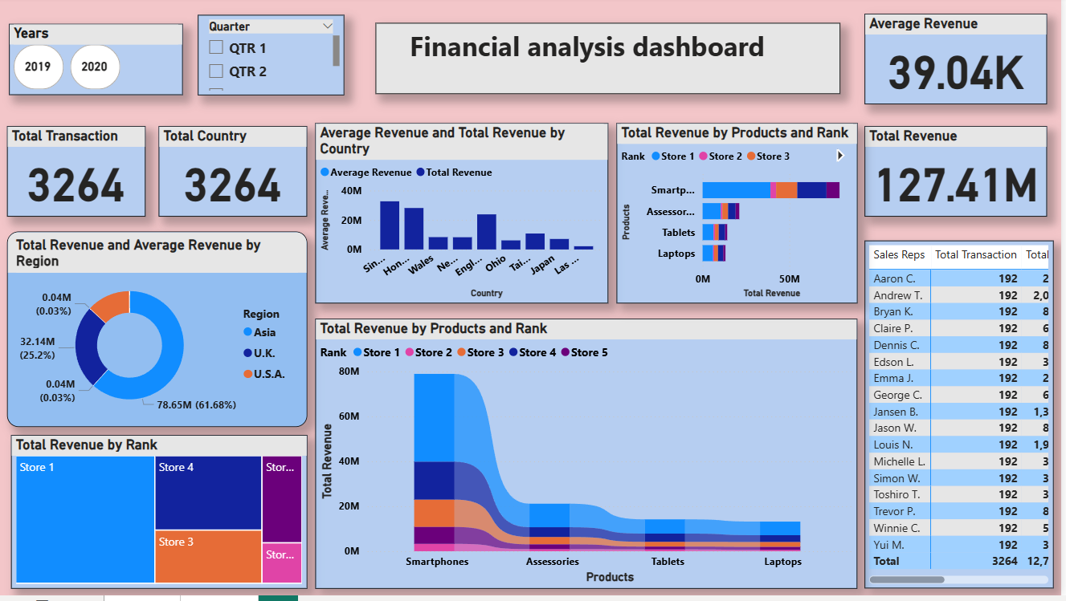

**Explanation**

Each visualization highlights relationships between financial performance, economic conditions, and market trends, aiding stakeholders in timely decision-making.

1. **Future scope**

* **Real-Time Data Integration**

Incorporate real-time financial news, earnings reports, and economic data via APIs for live trend detection.

* **Advanced NLP Techniques**

Utilize transformer-based models (e.g., BERT, GPT) for deeper semantic analysis and improved sentiment accuracy.

* **Sector-Specific Trend Analysis**

Expand the model to provide trend insights across specific industries (e.g., tech, healthcare, finance).

* **Integration with Trading Algorithms**

Use detected trends to inform automated trading systems or risk management tools.

* **Interactive Dashboards**

Build dynamic dashboards with filters for time, region, and sector to enable user-driven insights.

1. **Team members and their roles**

**Anuja k**

Coordinator of the team, data cleaning and creating a attractive dashboard

**Saranya k**

Deeply explain about the dataset description, system requirements

**Surya v**

Give explanation about the Project workflow (flowchart), project objectives

**Rajkumar L**

Give explanation about the exploratory data analysis (EDA) and data preprocessing